Statistics with R programming

Thanuja R

(192325004)

1.

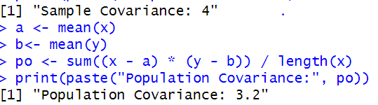

2.



